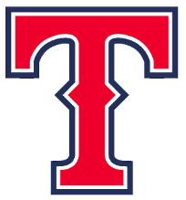
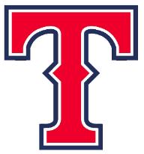
Tecumseh High School
All Sports Pass Agreement
2023-2024

Family Pass $225
Adult Pass $75
Adult 65+ Pass $50
Student Pass $50

All Sports Pass Guidelines:
- Passes are good for the individual/family member for whom it was purchased. Pass holders are NOT permitted to share passes with any for any reason
- When using an All Sports Pass, the actual pass must be presented for admittance to an event.
- Family passes are for IMMEDIATE family members living at the same residence – College school aged and under ONLY.
- These passes are valid for Tecumseh High School events only! Passes CANNOT be used for Tecumseh Middle School events.
- $10 replacement fee will be charged for all lost passes.
- Passes are good for regular season HOME contests only. Excludes all tournaments, Pocket Athletic Conference events, and IHSAA events.
- Passes will be revoked if not used within the stated guidelines. Any misuse of pass will result in the immediate cancellation of the pass. If this occurs, no refund will be given.

Please list the name(s) you want on the pass(es):

_________________________________ ______________________________________

_________________________________ ______________________________________

_________________________________ ______________________________________

By signing below, I am stating that I have read and agree with the All Sports Pass Guidelines and understand the pass must be present to gain admission to regular season athletic events.

Signature _______________________________________________Date _________________

