Mooresville High School
Softball Information 2023
Varsity – 11 West Carlisle Street, Mooresville

Our Varsity Softball Complex is located southwest of our high school on the other side of Carlisle Street. Please see map below for entrance and parking instructions.

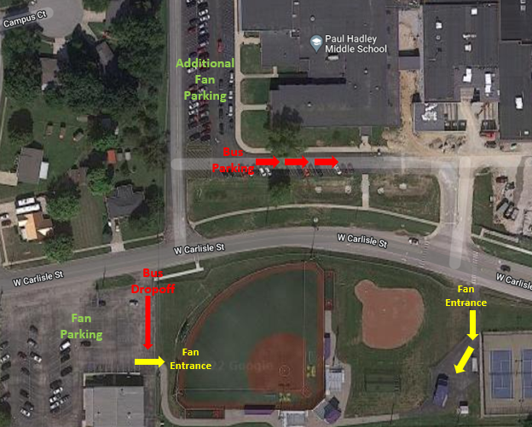

Tickets will be available at the gate or online
- Tickets are available at the gate (Cash or Card:
  - Single Game Ticket- $10.00
- Online (see link below)
https://public.eventlink.com/tickets?t=36174&p=50792

