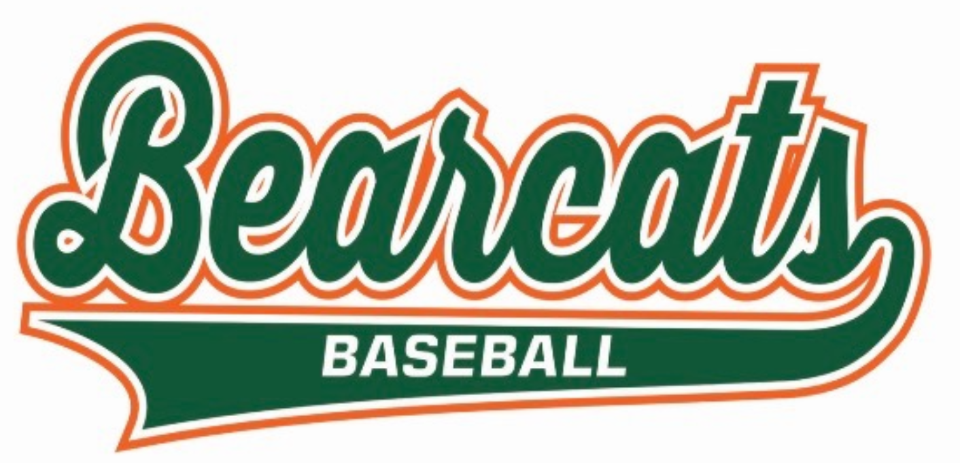
Wheeler Winter Baseball Camp 2024

Baseball season is almost here! The annual Wheeler Winter Baseball Camp will give players an opportunity to learn and work with Wheeler High School’s current varsity players and coaches. It is a 3 day camp designed for all skill levels. Players will be grouped by grade and skill level, and the camp will consist of individual skills, team play and competitions.

Grades: 1st-8th Grade
February 27 to February 29, 2024
Time: 6-7:30PM
Location: Wheeler High School Fieldhouse
Cost: $50 (includes a Wheeler Baseball T-Shirt)
Attendees should bring a bat, mitt, water bottle, and comfortable clothes to run around in (no cleats)

Please include payment in full with the application below. To pay by credit card, CLICK HERE. Make checks payable to Wheeler High School Baseball. If you have any questions, please email Coach Sean Cunningham at scunningham@union.k12.in.us. You can either mail or drop application and payment off to Wheeler High School Attn: Sean Cunningham, by February 16th. Walk in registrations will be accepted on February 27th, but you will not be guaranteed a T-Shirt. The shirt order needs to be submitted on the 16th.
************************************************************************************************************************

Player’s Name:____________________________________________ 2023/24 Grade:_______

Parent Phone Number:____________________ Email Address:_______________________________

T-Shirt: (Circle One) YS YM YL S M L

I grant permission for _____________________ to participate in the Wheeler Baseball Camp and waive and release Union Township School Corporation and staff from all claims for damage resulting from injury to the above named person or property while participating in or arising from his travel to or from the Wheeler Winter Baseball Camp.

_______________________________
Parent/Legal Guardian Signature

